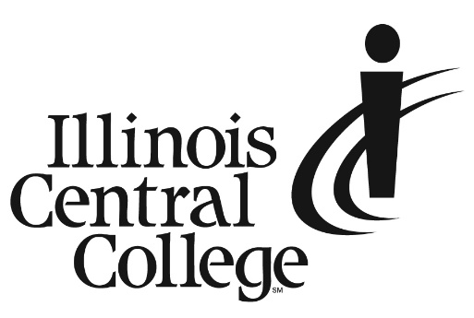
Press Release
MEDIA CONTACT:
Amanda Lewis
Senior Communications Specialist
Cell: 309-218-2305
Email: PR@icc.edu

FOR IMMEDIATE RELEASE
Illinois Central College Awarded Grants to Improve Dual Credit Access and Enhance EMT Training with Virtual Reality Equipment
East Peoria, IL (03/08/2024) – Illinois Central College (ICC) recently received two grants from the Illinois Community College Board (ICCB) totaling $204,018 through June 30, 2025.
The Access and Equity in Dual Credit Project grant awarded $149,958 to ICC to expand dual credit opportunities for high school students in Central Illinois, including Peoria Public High Schools, Pekin High School and Limestone High School. ICC will use the funds to train high school counselors and advisors, update college and career pathways and lower barriers to dual credit access for historically underserved students. The program will help more low-income students earn college credits while in high school.
The Career and Technical Education Virtual Reality grant provides the College with $54,060 to purchase virtual reality equipment and software to enhance recruitment and training for EMTs and paramedics. Both careers are in high demand in Central Illinois, and the new VR technology will give students more realistic learning opportunities to fully prepare them for entering the workforce. The equipment will also be used at recruiting events to show potential students what they can expect to experience in these careers and help meet regional job recruitment needs.
###
Illinois Central College is a two-year community college with campuses in East Peoria, Peoria, and Pekin, Illinois, providing a high-quality, affordable education to prepare students to enter the workforce or to transfer to a four-year college or university. For more information on ICC, visit icc.edu.

