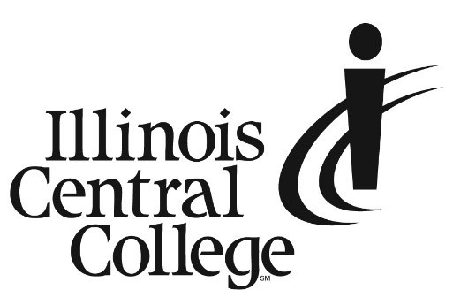

MEDIA ADVISORY
MEDIA CONTACT:
Jennifer O’Neil
Lead Coordinator,
Communications & Media Relations
Office: (309) 694-5527
Cell: (309) 218-2305
Email: PR@icc.edu

FOR IMMEDIATE RELEASE: SEPTEMBER 18, 2023

New Human Patient Simulator at ICC to Revolutionize Health Careers Training

Illinois Central College invites media to attend a National Simulation Week Open House to view demonstrations of a HAL® S5301 – High Fidelity Interdisciplinary and Immersive Patient Simulator. It is one of only four that have been delivered in the state of Illinois since hitting the market in early 2022.

The HAL® S5301 is touted as the most advanced simulator currently available in the world. It has AI-generated speech capabilities, can make facial expressions—including signs of stroke, move its arms, eyes, and head, and with its lifelike internal anatomy, HAL® S5301 can simulate an extensive range of symptoms and conditions. The simulator can also be used to practice surgery, respiratory procedures, emergency care, trauma intervention, and more.

Event Details:

Time/Date: Thursday, September 21, 2:00 – 5:00 PM

Location: ICC Peoria Campus Cedar Hall

Available for Interviews:
- Gregory Love, Coordinator of ICC Simulation & Skills Lab
- Mischelle Monagle, Associate Dean of Nursing
- Current ICC Health Science students
If you plan to attend or for questions, please contact ICC Lead Communications & Media Relations Coordinator, Jennifer O’Neil at jennifer.oneil@icc.edu, or (309)218-2305.
###
Illinois Central College is a two-year community college with campuses in East Peoria, Peoria, and Pekin, Illinois providing a high-quality, affordable education to prepare students to enter the workforce or to transfer to a four-year college or university. For more information on ICC, visit icc.edu.

